Melle Dijkstra

Melle210202@gmail.com

November 9, 2015

Description

The PDR is about the system requirements. And gives more in depth information about the project then the PCD (Product Concept Document). Also the planning + costs of the project will be described here.

Product Definition report

Cheery

# Table of contents

1 Table of contents 1

2 Organization 2

2.1 Contact Information 2

3 Detail Planning 2

4 The current situation & other similar projects 3

5 The new situation 3

6 The new social media 3

7 System Requirements 4

8 Evaluation Consequences 4

8.1 Description Base Structure 4

9 System Concept 5

9.1 Description System Concept 5

9.2 Scheme System Concept 6

10 Development Environment / Production Environment 6

10.1 System Development Environment 6

10.1.1 Hardware 6

10.1.2 Software 6

10.2 Production Environment 7

10.2.1 Minimal 7

10.2.2 Recommended 7

11 Implementation Procedure 8

11.1 Implementation 8

11.2 Acceptation 8

12 Overall Plan 9

12.1 Global Project Planning 9

12.2 Kosten/baten-overzicht 9

13 Conclusion and recommendation 9

14 List of terms and abbreviations 10

# Organization

For this project there isn’t really an organization for which the project will be made. It’s a school project so you could say the organization is the ROC Friese Poort.

## Contact Information

|  |  |
| --- | --- |
| Company Name | ROC Friese Poort |
| Address | Anne Wadmanwei 6 |
| City | Leeuwarden |
| Province | Friesland |
| Telephone | 058 233 9966 |
| Email | Info@rocfriesepoort.nl |

# Detail Planning

[Cheery Project Planner.xlsx](Cheery%20Project%20Planner.xlsx)

# The current situation & other similar projects

Currently there is no similar product because it’s a new innovative product and it will be built from the ground up. There are enough Social Media to look for similar features, however Cheery will have a unique approach. These systems can provide insight into how to solve certain problems.

Here are some current functionality and features from social media that already exist:

1. What you see a lot on social media is sharing info, updating posts, liking the posts and chatting. But it’s really pointed to yourself and how you put yourself in the picture.
2. Email to contact users about updates, notifications
3. Storing information about the user (first name, last name, etc.)
4. You can find other users, topics, information by searching on the site
5. You can chat through a messaging system
6. The feel of real-time updates, notifications
7. You can make friends with other people

# The new situation

The new situation will provide a new approach than the social media that already exist. The features and functionality will be new and modern which will provide a real challenge because of the mass of social media that is already there and might stumble across a steep learning curve. The functionality will focus on a new approach to handle the same data as the old approach. This project will create a new type of social media with different terms and different features that most social media have. Cheery is not going to be 100% social media. You can do things with friends, but that doesn’t mean it will also use posts, sharing information, liking what other friends do. It will actually be a place where friends can do things together and focus on a group and not on themselves.

Some features from Cheery that is different from other social media:

1. New points system where you can earn points and get rewards with them or you can do things with points so it stays fun to use.
2. No posting or sharing photos with other people (maybe only in the group)
3. Little challenges you can do with the group

# The new social media

With this new (type of) social media we people will be much more busy entertaining the group(s) they are in or playing with their group(s) instead of sharing everything they do in their lives with the whole world and wanting to have more and more attention.

# System Requirements

The functionality which the project will have are listed here:

1. Creating/Registering a user
2. User can log in
3. The system can uniquely identify the different users
4. User can see his own profile
5. User can see other users’ profiles
6. User can create group
7. Users can join groups
8. The design has to look good (materialize)

# Evaluation Consequences

## Description Base Structure

# System Concept

## Description System Concept

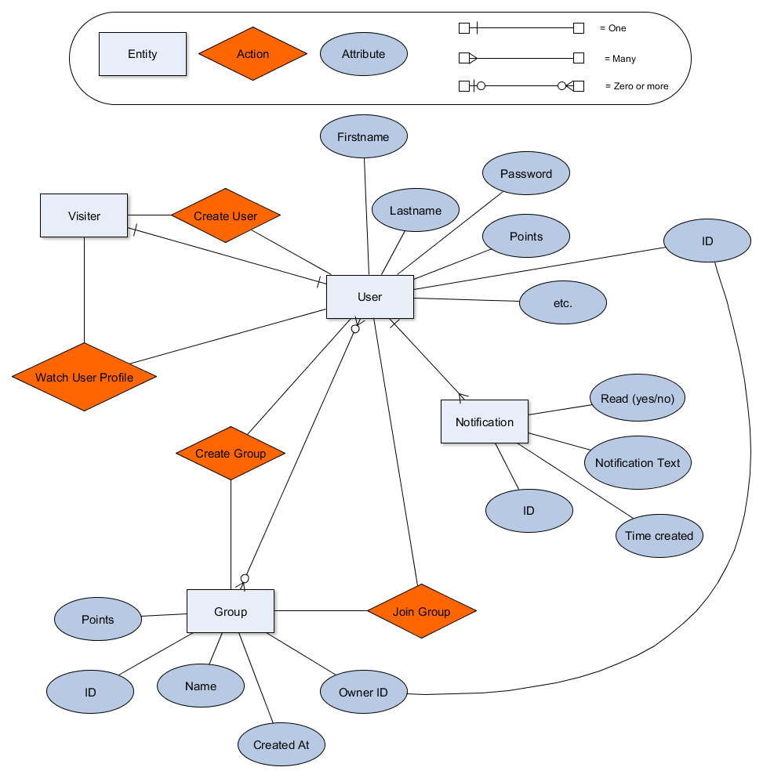The base structure of the project should look like the ER-Diagram below. This is continuously changed during the development time. But this should be a strong base on which can be built on and can be improved to a more complex structure. In this base structure there are mainly users and groups. Noted in the diagram is that users can be in multiple groups and that groups can have multiple users. When a visitor visits the site for the first time he doesn’t have a user account. A visitor can create a user account which then will be a user account for that visitor only (one to one).

## Scheme System Concept

Hier komt het contextdiagram en 1e niveau DFD òf een (blok)schema van bijvoorbeeld het netwerk.

Daarnaast een uitleg van wat het voorstelt. Aanvullen met uitdraai uit de SE van de gebruikte symbolen.

Tip: Vul de SE in bij elk symbool. (SDW-pictogram met boeken).

# Development Environment / Production Environment

## System Development Environment

In this chapter the system development environment will be described and the tools and services needed to realize the program will be described here in detail. The development environment is the place where the application gets realized. Then when it’s finished it will go to the production environment. Here are listed some hardware and software requisites for developing the application.

### Hardware

Hardware are the machines, wiring, and other physical components of an electronic system.

#### Server

The server is the computer/machine that will be running the application. For developing the server will be used but with a separate subdomain for development dev.cheery.nl.

#### Development Virtual Host

As said above a subdomain will be used for development but is stored and running on the same server as the production environment. A virtual host will be made to make that possible.

### Software

Software are the programs and other operating information used by a computer. With this software it will be possible to make the actual application, store the application data and much more.

#### PHPStorm (IDE)

The IDE that is used to make the application will be PHPStorm. For more information see this link

[PHPStorm](https://www.jetbrains.com/phpstorm/documentation/)

#### Android Studio / Cordova (app development)

If there is enough time to develop an app or if there will be in future times it will be developed in Android Studio or Cordova. For more information see these links:

[Android Studio](http://developer.android.com/tools‎)

[Cordova](https://cordova.apache.org/)

## Production Environment

The production environment will be the scenario that has a finished stage and needs to meet all requirements for a user to have a good experience. This means for example that the interface has to look good and isn’t buggy were buttons are placed on wrong or some elements are hidden which can break the use of an application.

### Minimal

The minimal requirements to use the Cheery application / website so you can do the basic interactions and have a good enough layout and flow of the application.

* Computer with internet access
* Browser with JavaScript enabled
* Browser list here:
  + Chrome 25
  + Internet Explorer 9
  + Opera 15
  + Firefox 20
  + Safari 5

### Recommended

The recommended requirements to get the maximum experience with this application are simply a regular or faster computer with the latest browsers installed which at the current date are the list below:

* Chrome 47
* Internet Explorer 11 (or edge)
* Opera 33
* Firefox 42
* Safari 10.11



# Implementation Procedure

## Implementation

The implementation should be quite simple. The development environment (DE) will be located at dev.cheery.nl. The production environment (PE) will just be cheery.nl which is also located on the same server as the DE. The application is made with the majority of relative paths to locate resources or redirect users. So there only should be a few absolute URL’s that need to be changed before implementation. The PHP libraries and other resources that aren’t requested by the visitor will be located outside the web-root. The application will use absolute URL’s to get those libraries so transferring the application to another directory should go without failure.

The most important aspect of changing from development to production is the technical error reporting. This should be turned off for every part of the application.

The procedure for converting the DE to the PE will have the following steps:

1. Transfer all the libraries from the DE to the PE
2. All absolute URL’s used in the DE should be changed to the associated URL from the PE
3. Then transfer all the main files from the DE to the PE
4. Check if something went wrong by going to [cheery.nl](http://cheery.nl), fix all errors that show up
5. If everything seems ok, turn off all error reporting for e.g. apache, PHP, MySQL, frameworks

## Acceptation

The acceptance of the application will contain the following components:

First of all the application has to be reachable by multiple devices. These devices are primarily personal computers but also smartphones or some type of device with internet access. This doesn’t mean that it’s visually perfect on those devices.

Creating users and groups is a vital part of the application and should be visually and functionally easy to accomplish on most commonly used devices.

Easy steps and a visually attractive layout is a fundamental feature to have a good understanding of the application. The visual components should be shown in a convenient way so that the functionality behind it is easy to understand.

# Overall Plan

## Global Project Planning

Stel een planning op van het gehele project. Later wordt er per fase een detailplanning gemaakt.

## Costs and Benefits Overview

The costs for the server are $5 p/month at Digital Ocean. Digital Ocean is very flexible with changing hardware like SSD storage or RAM upgrades. Neostrada has a different paying system. The first year the costs for a domain name are €3,57 because they have an offer for this year. Then you can extend the lifetime of your domain for different prices. Extend for 1 year it will cost €8,99, extend for 2 years it costs €13,9 and extending for 3 years costs €17,85.

|  |  |  |  |  |
| --- | --- | --- | --- | --- |
| Categories / Subject | Starting Costs | Cost p/Month | Costs 1ste year | Coming years |
| Server ([digitalocean.com](http://www.digitalocean.com/)) | $5 (€4,56) | $5 (€4,56) | $60 (€54,66) | $60 (€54,66) |
| Domain Name (cheery.nl) | €3,57 | €0 | €3,57 (normal €8,99) | €8,99 |

# Conclusion and recommendation

Activiteit 1.10 – Valideer Informatieplanning en definitiestudie.

Trek conclusie uit de voorgaande activiteiten en maak een aanbeveling naar de opdrachtgever.

Zoals GO/NO-GO, etc.

Lever het rapport ter goedkeuring in bij de opdrachtgever.

Na goedkeuring van de opdrachtgever kan het bijgewerkte rapport ter beoordeling ingeleverd worden bij de teambegeleider.

Wat kon beter? Andere aanpak? Resultaat tot nu toe?

# List of terms and abbreviations

A list with terms and abbreviations is described here for the difficult words used in this document. The document should already be as clear as possible without a lot of difficult terminology, but there are always a few hard to understand.

The list is sorted alphabetically.

|  |  |
| --- | --- |
| *Term / Abbreviation* | *Description* |
| Development Environment | The development environment is the set of processes and programming tools used to create the program or software product and/or the state of the application in development |
| ER-Diagram | A diagram/scheme that represents entity relations in a program/application |
| IDE (Integrated Development Environment) | The application that provides comprehensive facilities to computerprogrammers for software development. AnIDE normally consists of a source code editor, build automation tools and a debugger. |
| Production Environment | The location or state from the application |

|  |
| --- |
| *ACCEPTATIONFORM INFORMATION PLANNING & DEFINITION STUDY* |
| Project : Cheery |
| Projectfase : y |
| Subject : Acceptation report Information planning & definition study |
| Sign the form and the listed conditions below will be accepted |
| Date: |
| Name + signature projectleader: |
| Name + signature customer : |